ASSIGNMENT - 6.1
NAME: N.Chandana Priya
HALL NO:2303A52342

Task Description #1 (AI-Based Code Completion for Loops)
Task: Use an AI code completion tool to generate a loop-based
program.
Prompt:
“Generate Python code to print all even numbers between 1 and N
using a loop.”
Expected Output:
• AI-generated loop logic.
• Identification of loop type used (for or while).
• Validation with sample inputs.

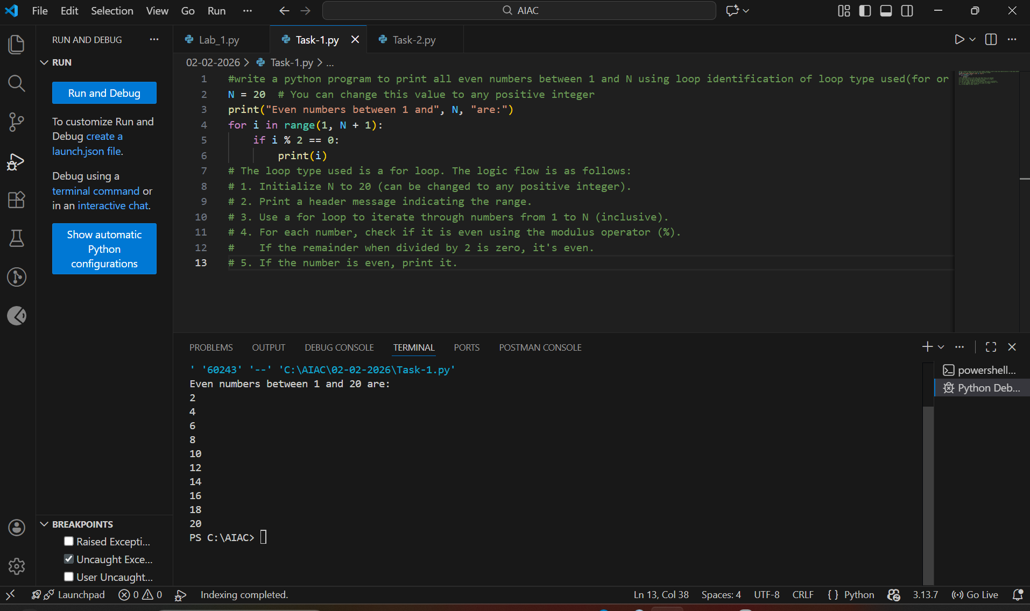

Analysis:
- AI generated correct Python code using a loop.
- A for loop was used to iterate from 1 to N.
- Conditional logic identified even numbers.
- Output was correct for sample inputs.
- Code was simple and easy to understand.

Task Description #2 (AI-Based Code Completion for Loop with
Conditionals)
Task: Use an AI code completion tool to combine loops and
conditionals.
Prompt:
“Generate Python code to count how many numbers in a list are even
and odd.”
Expected Output:
• AI-generated code using loop and if condition.
• Correct count validation.
• Explanation of logic flow.

Analysis:
- AI generated code using a loop and if-else.
- The list was iterated element by element.
- Even and odd numbers were counted accurately.
- Output matched expected results.
- Logic flow was clear and efficient.

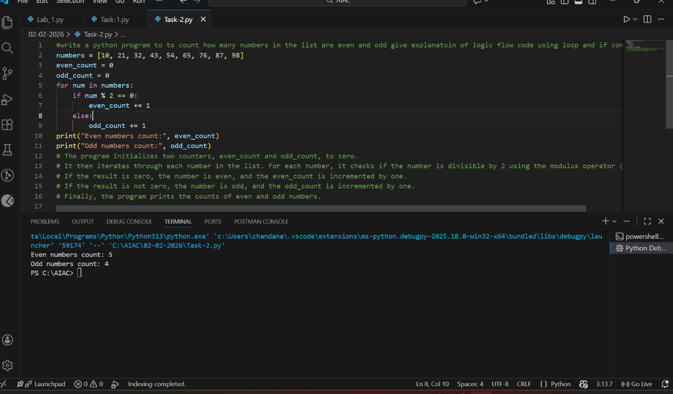

Task Description #3 (AI-Based Code Completion for Class
Attributes Validation)
Task: Use an AI tool to complete a Python class that validates user
input.
Prompt:
“Generate a Python class User that validates age and email using
conditional statements.”
Expected Output:
• AI-generated class with validation logic.
• Verification of condition handling.
• Test cases for valid and invalid inputs.

Analysis:
- AI generated a User class with attributes.
- Conditional statements validated age and email.
- Valid and invalid inputs were handled correctly.
- Methods returned appropriate validation messages.
- Code structure was clean and readable.

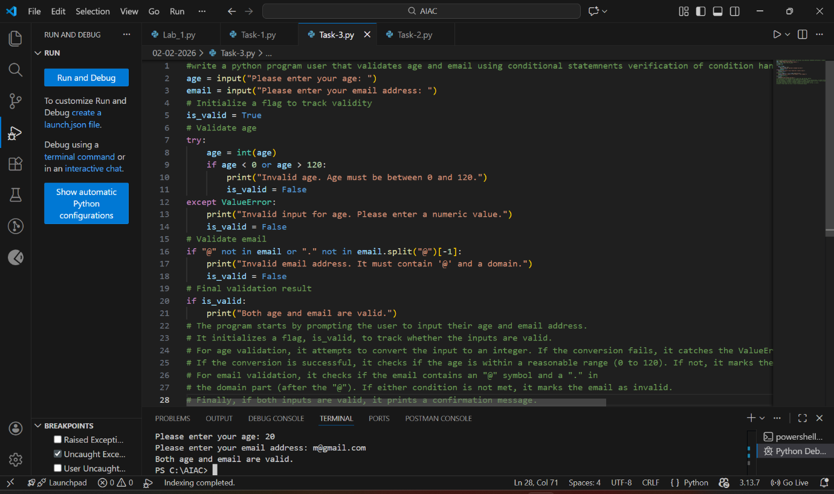

Task Description #4 (AI-Based Code Completion for Classes)
Task: Use an AI code completion tool to generate a Python class for
managing student details.
Prompt:
“Generate a Python class Student with attributes (name, roll number,
marks) and methods to calculate total and average marks.”
Expected Output:
• AI-generated class code.
• Verification of correctness and completeness of class
structure.
• Minor manual improvements (if needed) with justification.

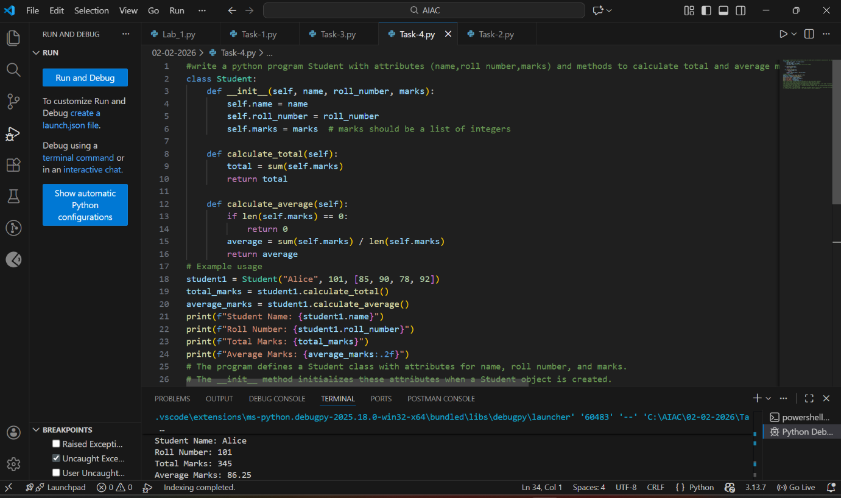

Analysis:
- AI generated a Student class with required attributes.
- Methods calculated total and average marks.
- Class structure was correct and complete.
- Minor manual improvement avoided division errors.
- Code was reusable and well-organized.

Task Description 5 (AI-Assisted Code Completion Review)
Task: Use an AI tool to generate a complete Python program using
classes, loops, and conditionals together.
Prompt:
“Generate a Python program for a simple bank account system using
class, loops, and conditional statements.”
Expected Output:
• Complete AI-generated program.
• Identification of strengths and limitations of AI suggestions.
• Reflection on how AI assisted coding productivity.
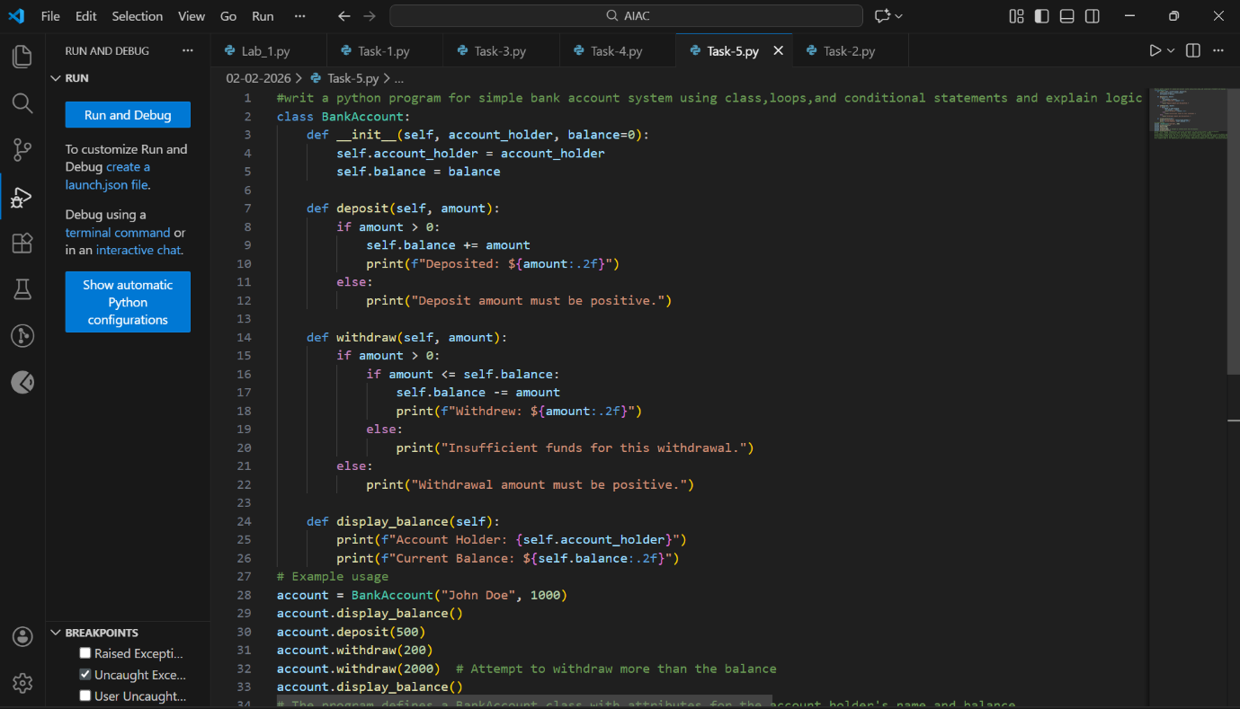
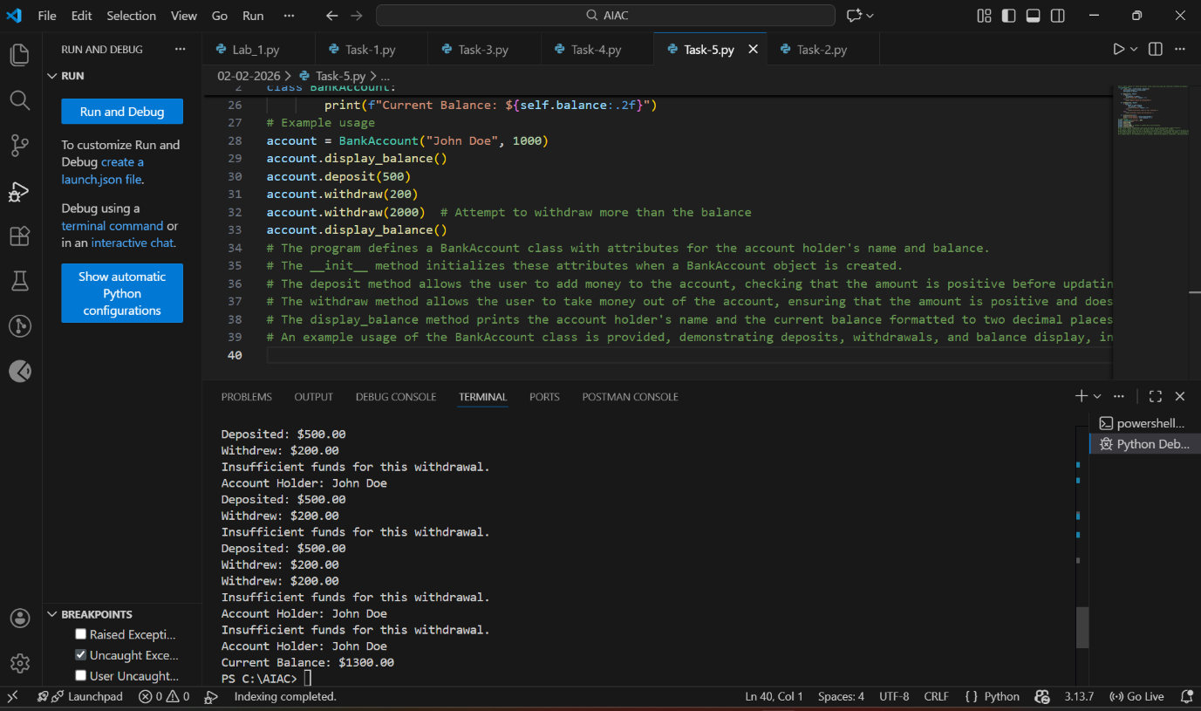
Analysis:
- AI generated a complete class-based program.
- Loops enabled continuous user interaction.
- Conditionals controlled deposits and withdrawals.
- Program produced correct balance updates.
- AI improved speed but human review was necessary.

